D02 – Domain models Responsibility statements

# Identification data

*24 A+* [*https://github.com/DP1819/D02*](https://github.com/DP1819/D02)[*https://trello.com/b/yMJVk378/entrega-d02*](https://trello.com/b/yMJVk378/entrega-d02)

Group Level URL of your project and your artefact management systems

Seville, October 31, 2018

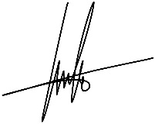Place, date

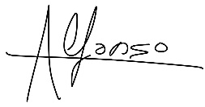

de la Oliva Aguilar, Juan Manuel

Alarcón Tamayo, Alfonso

Student #1: Surname, name, and signature Student #2: Surname, name, and signature

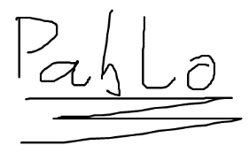

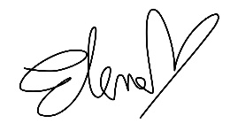

Pino Jiménez, Pablo

Molina Pineda, Elena

Student #3: Surname, name, and signature Student #4: Surname, name, and signature

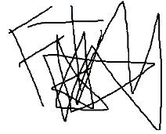

Trinidad Márquez, Felipe

Student #5: Surname, name, and signature

# Responsibility statements

[✓] I am an author of this deliverable. I have not cheated in any way.

[✓] I have collaborated with my partners on producing this deliverable; in other words, neither have I ridden their coattails nor gobbled them up.

[✓] I have learnt from working on this deliverable, so that I can pass my control checks.

[✓] I have organised this deliverable according to the guidelines that are available in document “On your deliverables.pdf”, which is available at the USE’s e-learning platform.

[✓] I understand that my deliverable will be considered failed if I fail to meet any of its require- ments, if I fail to submit it by the deadline, or if I do not deliver a filled copy of this form.

[✓] I understand that failing this deliverable might amount to failing the subject.

[ ✓] I understand that I must have a contingency plan and that submitting my deliverable very close to the deadline is likely to result in disaster.